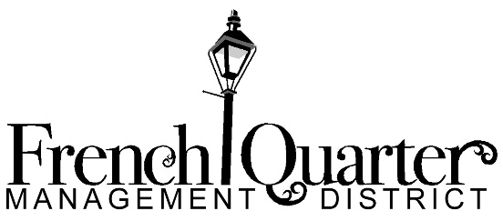
Thursday, January 24, 2018
2-3pm
400 North Peters, Suite 206
New Orleans

Government Affairs Committee Meeting Notes
Members present: David Bilbe, Jeremy DeBlieux, Brian Furness, Kim Rosenberg
Members absent: Brittany McGovern, Christian Pendleton

Guests: Emily Remington

Meeting called to order at 2:08pm. Rosenberg moved to amend the agenda to approve the previous meeting’s notes. Furness seconded. All agreed. The previous meeting’s notes were amended for a typographical error. Rosenberg moved approval. Bilbe seconded. All approved.

DeBlieux asked Rosenberg to review the process to extend FQMD’s sunset. Rosenberg informed the Committee that Wednesday, February 13 is the deadline for submission. Legislation will need to be drafted and advertised in the Advocate 30 days before pre-filing. Members discussed potential sponsoring legislators (Representative Royce Duplessis, Senator Wesley Bishop, Senator JP Morrell, and Senator Karen Carter-Peterson) and their district boundaries. Furness agreed to contact Duplessis, and Rosenberg agreed to contact Carter-Peterson. Rosenberg described the to-be-proposed legislation changes. DeBlieux thanked Rosenberg for her efforts.

DeBlieux distributed copies of the municipal and state codes regarding the illegal carrying of weapons. DeBlieux recapitulated a conversation he had had with Commander Gernon of the NOPD’s 8th District; no municipal charges are felonies, so NOPD always arrests on the state charge. Members discussed the viability of a state law change for legislation for the French Quarter. Members discussed the potential, including political will, for the French Quarter to become a state park. DeBlieux suggested that he reports back to the Board that arrests do not happen on a City (municipal) level.

Rosenberg informed the Committee that the French Quarter is a national park. Discussion continued about the French Quarter’s state, national, and historic designations and ways to increase the penalties for illegally carrying a firearm.

Meeting adjourned at 2:42pm.

